Section 1 – Contact & Event Details
Booking ID………….... Deposit received on ………..….………
Invoice No……………..

Name / Organisation | Name
Invoice Address | Invoice address
Daytime Contact No | Phone number | Mobile |  | Mobile number
Email | E mail
Responsible Person who will be at the Event | Name |  | Number

Event Date | Date of Event | Type of Event | Type here
Event Start Time  (incl set up time) | Time | Event End Time  (incl clear out time) | Time
Total Time Booked | Number of hours | Number Attending (approximately) | Number
Caterer name & Contact Details (if applicable) | Details

Section 2 - Use of space/ equipment required and charges
Total £
Main Hall | Exercise Class |  |  | Yes/No |  | Number of Hours: hours at £27.00 Inc VAT per hour |  |  | £ type here
 | Local Rate (enclose a copy of council tax bill) |  |  | Yes/No |  | Number of Hours: hours at £33.00 Inc VAT per hour (Minimum 3-hour hire) |  |  | £ type here
 | Standard Rate |  |  | Yes/No |  | Number of Hours: hours at £42.00 Inc VAT per hour (Minimum 3 hours) |  |  | £ type here
 | Day Rate |  |  | Yes/No |  | 8 hours between 08:00 to 18:00 £285.00 Inc VAT |  |  | £ type here
Green Room |  | Hired with Main Hall |  |  | Yes/No |  | Number of Hours: hours
 |  | Hired separately from Main Hall |  |  | Yes/No |  | Number of Hours: hours at £15.00 per hour Inc VAT (Subject to Availability) |  | £ type here
Council Meeting Room |  |  |  | Yes/No |  |  | Number of Hours: hours at £20.00 per hour Inc VAT |  | £ type here
Kitchen area for food preparation / Bar service (see over page) Yes/No £60.00 Inc VAT  Kitchen area for tea / coffee / light refreshments or bar Yes/No £33.00 Inc VAT |  |  |  |  |  |  |  |  | £ type here
Film screen Only (7m x 4 m) |  | Yes/No |  |  |  |  | Data Projector Hire £54.00  Yes/No |  | £ type here
Lighting rig |  | Yes/No |  |  |  |  | Raked seating extended (up to 190 seats) |  | Yes/No
10 ft Trestle tables  (max 18) |  | number |  |  |  |  | 6ft trestle tables  (max 12) | number
Music |  | Live? Yes/No | Recorded? Yes/No |  |  |  | PA System |  | Yes/No
Brief description of your event:Type here |  |  |  |  |  |  | How many performers attending? |  | number

Payment
Total amount | £type here | 25% deposit enclosed with this form | £ type here

Payment can be made direct to:
Bradford on Avon Town Council Sort Code: 30 98 75 Account No 01236757
Please use your event date as a reference.

Section 3 – Alcoholic Bar
If an alcoholic bar is required (please indicate hire of kitchen - bar is not stocked or staffed) it is the responsibility of the applicant to provide adequate supplies and staff. The Hall Manager is the Licensee. Please complete details below to operate under our licence (please give as much information as you have at present – further details can be added nearer the event). Bradford on Avon Town Council reserve the right to refuse permission for alcohol to be sold if arrangements are considered unsatisfactory. No person under the age of 18 will be able to purchase or consume alcohol on the premises.
What hours will the bar be open? | Time
2 or more responsible adults over the age of 21 be on duty at the bar throughout the event? | Yes/No
How many persons under the age of 18 will be admitted to this event? | Number
How many responsible adults will be available to supervise those under 18 at the event? | Number
Will professional door security staff be employed to restrict entry and if so how many? | Yes/No
Will tickets for your event be sold on the door? | Yes/No
Will tickets for your event be available on sale to the general public and where? | Yes/No Where?
Will you be using reusable plastic (no single use plastic please) or glass drinking vessels? (if raked seating used – please note glassware and hot drinks are not permitted in the seating area) | Yes/No
Will your guests be mainly seated in rows, at tables or standing? | Type here
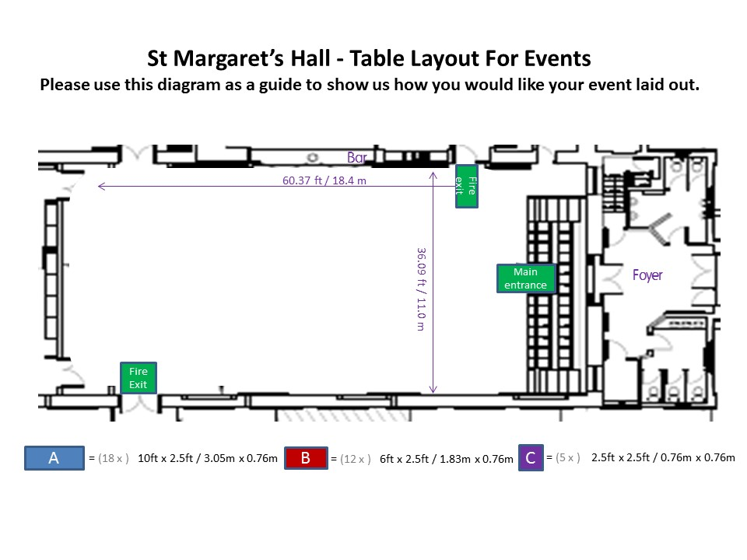

I confirm that I have read and understood the full terms and conditions of hire (dated 01/04/23) and agree to abide by them. I enclose a copy of our public liability insurance certificate (organisations and businesses only, if appropriate). I understand that if I exceeded my booked time or make use of non-booked facilities these extra costs will be invoiced after my event. Extra time is charged per half hour. I understand that any changes to the requested set up of the hall will be at the discretion of the Duty Manager.

Print name: Click or tap here to enter text. Signature:Click or tap here to enter text. Date:Click or tap to enter a date.
Section 4
Charges from 1 April 2023 (all prices inclusive of VAT)

Hire Charges

Standard Rate
£42.00 per hour (min 3 hrs) to include: Green Room as a dressing room, projection room, lighting rig and PA system.

Local Rate
£33.00 per hour. This is a discounted rate for local Bradford on Avon council tax payers, local non-profit making and fundraising organisations. A copy of your latest Council Tax bill will be required.

Day Rate (for all non-local hirers)
£285.00 for 8 hours any time between 08.00 – 18.00 hrs (then £42.00 per additional hour – no local discount applicable).

Exercise Classes
£27.00 per hour for classes held weekday mornings between 9.00 – 14.00 hrs when no Duty Manager or setup is required and at the discretion of Town Council Officers - normal rules & charges apply at all other times.

Kitchen Hire
£33.00 per session, including crockery: (cups (100), saucers (100), teaspoons (100), tea urn, soup bowls and spoons (60), polycarbonate wine glasses (100), pint and half pint glasses (100)
£60.00 per session when used for food preparation and service using cooker and hot cupboards.

Projector & Screen Hire
St Margaret’s Hall is equipped with a 7500 lumen Christie projector mounted on the lighting truss and a 7m by 4m cinema screen. The projector is available to hire for either showing films using a Blu-ray player or connecting to a laptop using a VGA or HDMI connectors. The hire charge is £54.00.

Green Room
If the Green Room is hired as part of a main hall hire there is no charge.
If the Green Room is hired separately from the main hall booking, the hire charge is £15 per hour (the Green Room is subject to availability and is only accessible by three flights of stairs).

Council Meeting Room
Available to hire subject to availability at £20 per hour.

Surcharge
Bank holiday and New Year’s Eve - 60% surcharge.

Cleaning Deposit
A refundable cleaning deposit of £60.00 may be required at the time of booking to cover any additional cleaning/clearing up/rubbish removal that may be necessary for events e.g. wedding receptions, birthday parties, events with alcohol etc.

Booking Fee
There is a non-returnable booking fee of 25% of the hire fee payable at the time of booking and the balance to be paid 2 weeks before the event (not applicable to regular events). Provisional bookings will be held for 2 weeks from the enquiry date.

Cancellation
When a cancellation of a booking is received in writing the following charges apply:
(less non-refundable booking fee)

28 days or more in advance -75% refund - 25% payable, 27-21 days in advance - 75% refund - 25% payable
20-14 days in advance - 50% refund - 50% payable, 13-7 days in advance - 15% refund - 85% payable,
6 days before due date - No refund - full amount payable.
